ENGLISH

**Tiffany Caoxu**

China

Founder & CEO of Tcube

1. Math & Financial Risk Management Honor from University of Minnesota
2. Actuarial Science Master from Columbia University
3. Founder of Tcube
4. Co-Founder of Yuanhe Investment Co
5. Deputy Secretary General of US Chapter- SORSA
6. Co-Chair of Big10 Alum Associations

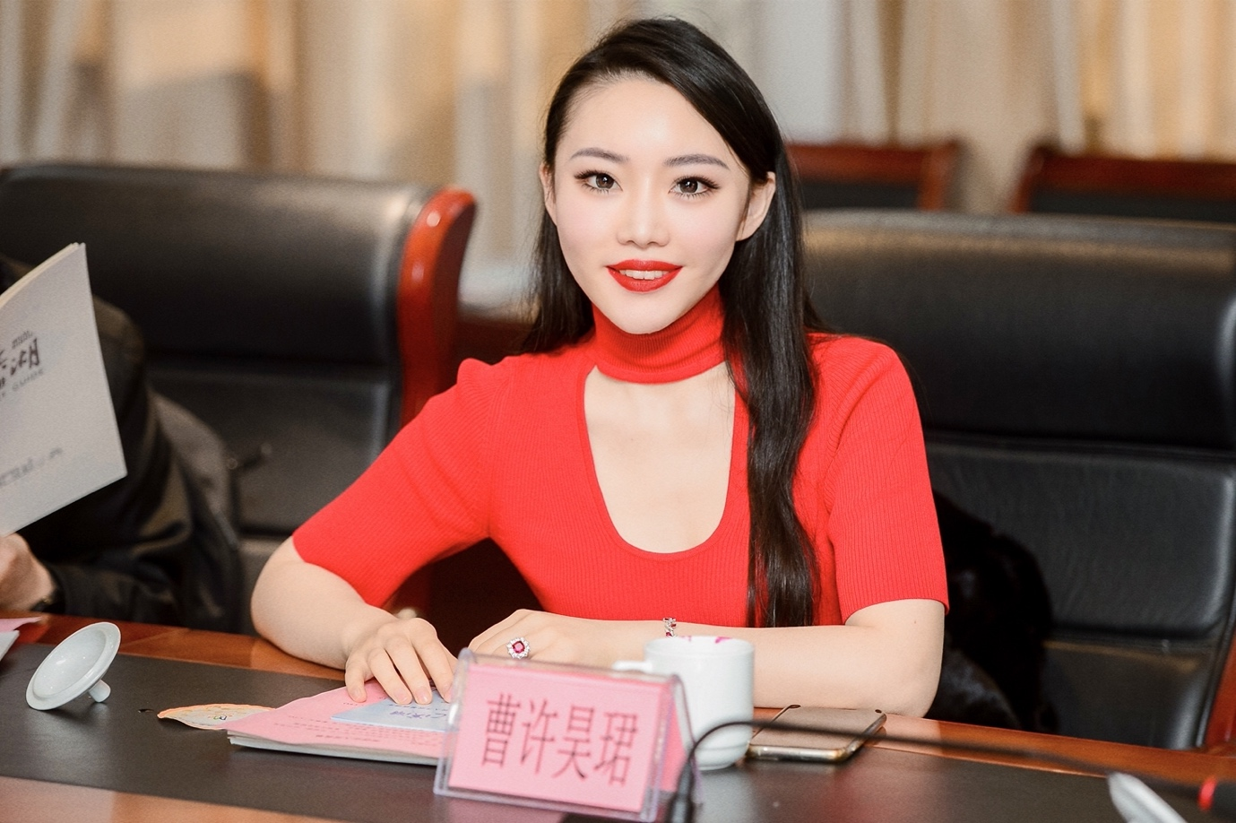

“I got acquainted with TEC in an educational companion project sharing session that I’ve initially invested in. I resonated with TEC's value and was deeply affected by TEC's efforts to Build A Home Away From Home for foreigners for many years. It is always hard to imagine so many activities and large Fairs were organized by a team of only a few full-time staffs. From paying attention to TEC's activities, workshops, to participating in the activities as a volunteer at the Christmas charity gala, helping to promote the TEC mini program... there are many I’d hope to contribute to this community and bring more strategic partners on board to help TEC build charitable activities together. I look forward for the future!”

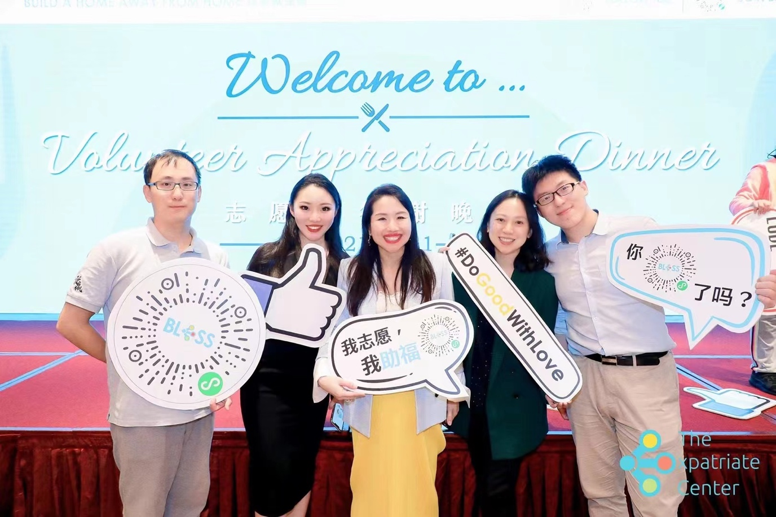

中文

**曹许昊珺**

中国

Founder & CEO of Tcube

1. 明尼苏达大学数学&金融风险管理荣誉双学位

2. 哥伦比亚大学精算数学硕士

3. Tcube创始人

4. 元阖投资管理联合创始人

5. 欧美同学会留美分会副秘书长

6. Big10北美十校联盟上海联席主席

“与TEC结缘于最初投资的一个教育陪伴项目的公益讲座，认同TEC的理念并为该组织多年以来为外籍人士建立家外之家的努力所感染，始终难以想象这么多丰富的活动，大型的展会是由我们仅仅数人全职的团队一手打造的。从留意TEC办的活动，工作坊，到参与其中，作为圣诞筹款晚会的志愿者，协助TEC助福小程序的推广… 还有更多希望能为这个集体贡献的，愿为TEC带来更多的战略合作伙伴助力共同建设公益活动，期待未来！”

